**Project:**  
**-** Study Scheduler

**Project Brief:**

Our project, the Study Scheduler, provides users a way to help manage their exams, assessments and study tasks. By promoting digital wellbeing, we aim to enhance users’ productivity to accomplish their study goals. The features of the Study Scheduler includes a calendar to plan tasks, a study timer to keep focus, task reminders, helpful study techniques and data on study habits to aid our users to plan and achieve their study goals.

**Stake** **Holders**

* Students
* Users with task deadlines

**Tech Stack**

* Java
* Java Effects
* IntelliJ
* Calendar API?
* SQL Database

**Project Management**

* Trello (Scrum Template)
* GitHub (version control)

**Communication**

* Discord
* Email
* Trello assigned tasks

**Requirements (NOT 100%):**

*Authentication System* -> Allow for users to sign on with an individual, local username and password. User data can be exported/reside in file shares for use across multiple computers.’

* Will require the use of a local database with implementation in Java.
* Database will store information containing the user’s schedule in relation to the features of the application (ex; upcoming exams, allocated periods to study, etc).
* Secure storage of user information (hashing & salting passwords).
* Example of an oversimplified ERD:  
  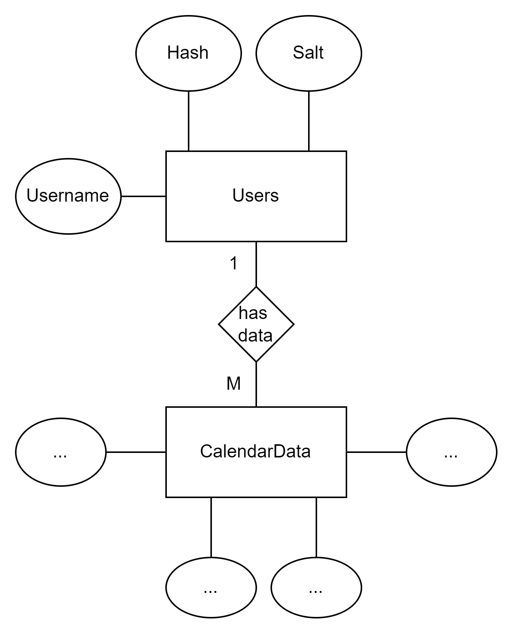

*Calendar* -> Provide the user with the ability to view upcoming events.

* The user will need to be able to insert/add events into their calendar.
  + CRUD operations for all Calendar events.
* Schedule/allocate periods of time in the application for studying.
  + Supports various studying techniques, ex; pomodoro.
* Events in the calendar will link into the *Insights* section for the application.

Insights-> Provide the user with insight in relation to their studying habits (as measured within the Calendar).

* Set goals (amount of time studied before a set date, etc).
* Other statistics related to the students current studying-habits and areas to improve.

Graphical user interface - Intuitive well-designed GUI that allows users to perform all functions of the application.